Web Authoring Assignment 2A

Name: Sonny Milbourn

Student ID: 16600221

Contents:

Wireframe

Sitemap

2x Peer Reviews

Self-reviews

Website Screenshots

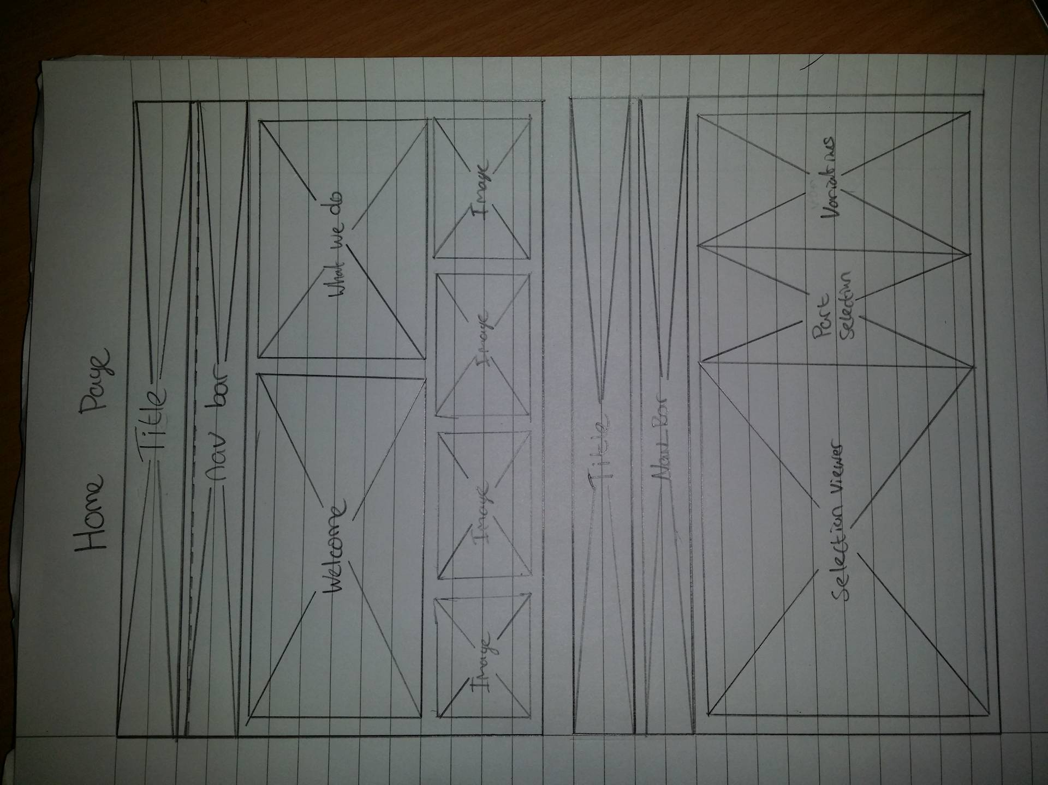Home page

Customisation Page

‘Contact’ page

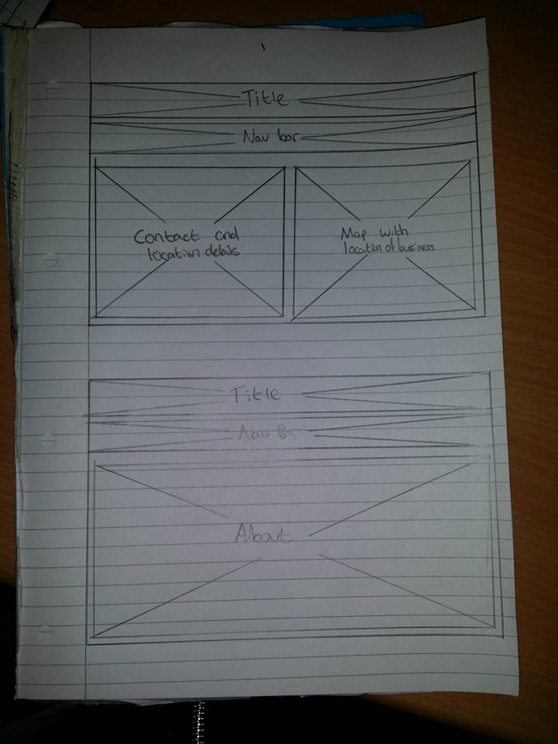

‘About’ page



Custom Bicycles site-map

Home Page

About Us

Contact Us

Customisation

Homepage

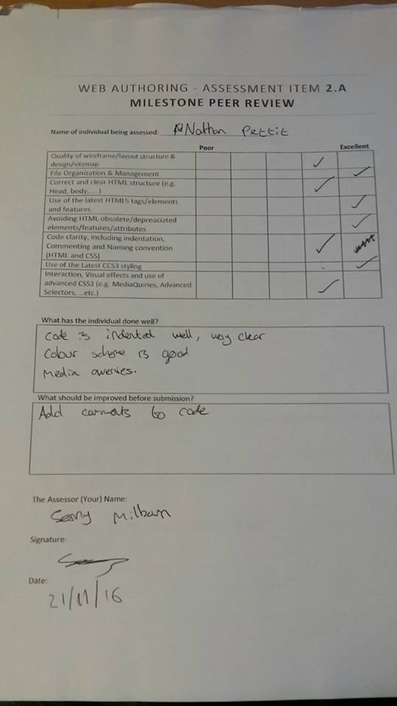

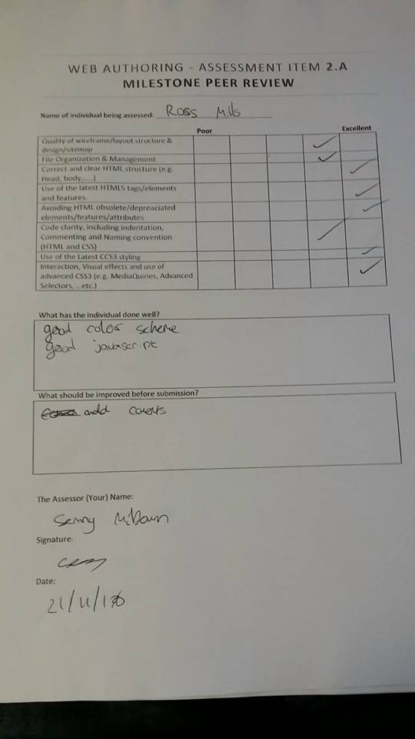

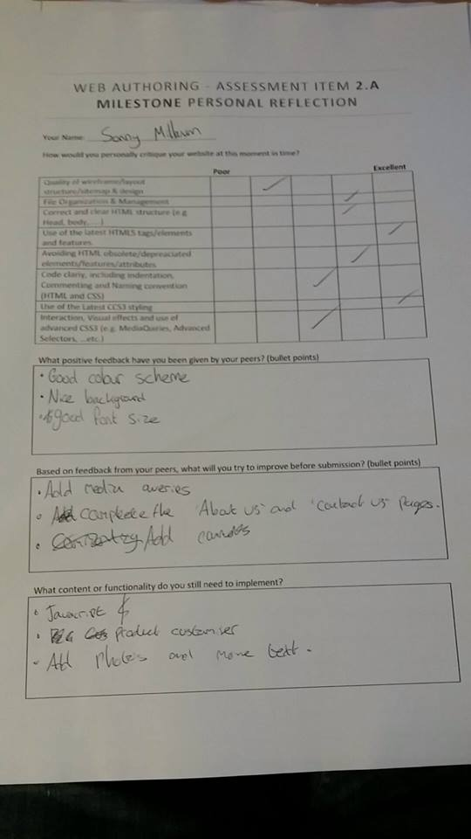

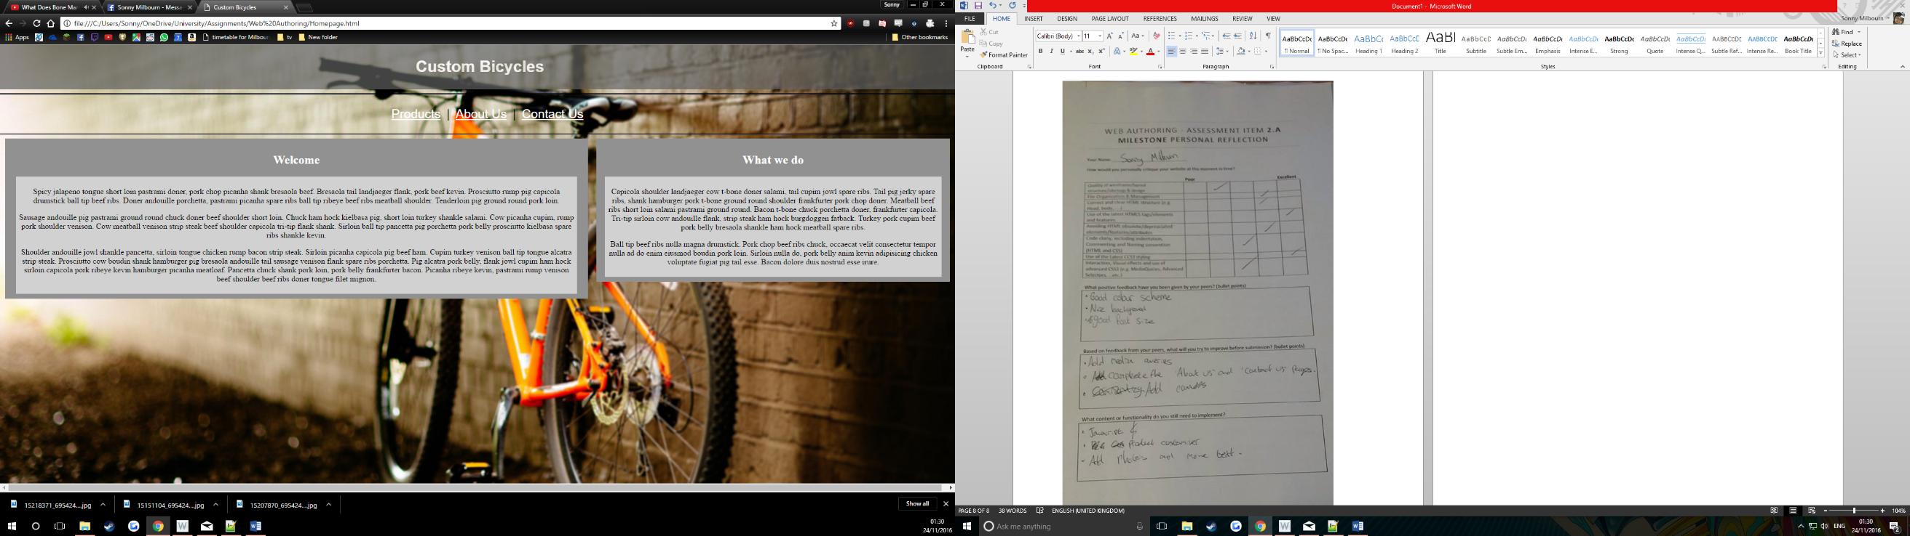Homepage

Customisation

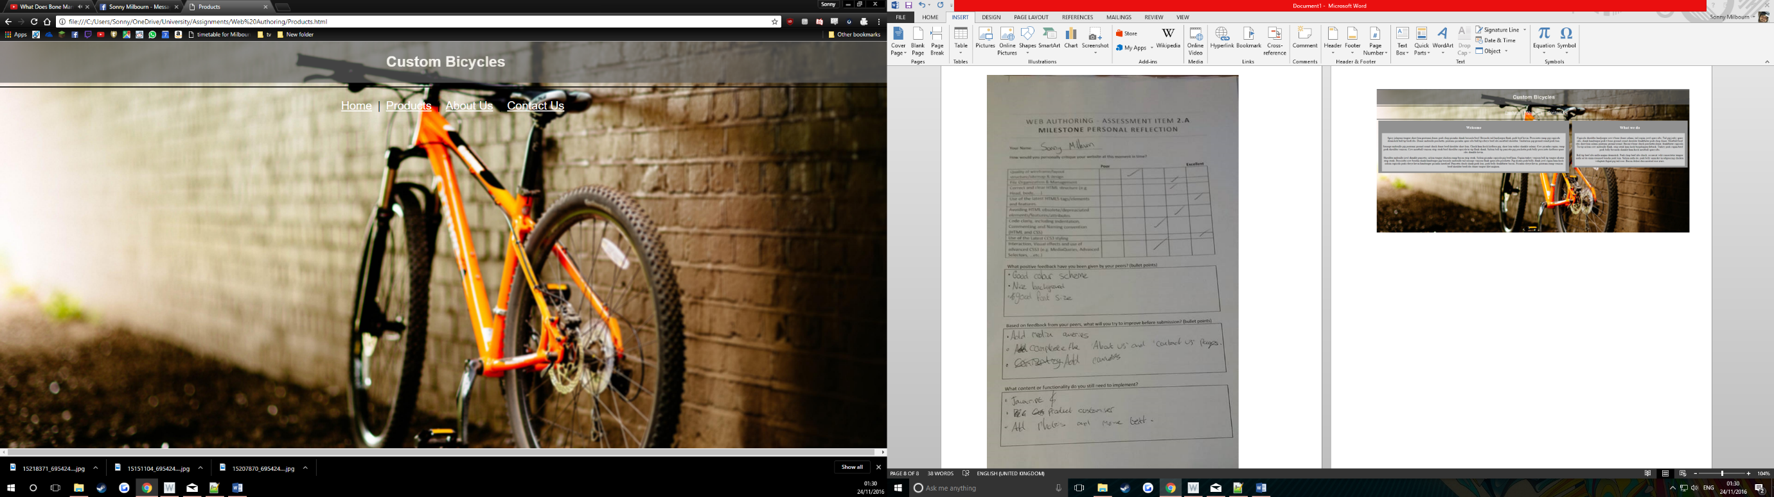

About us page

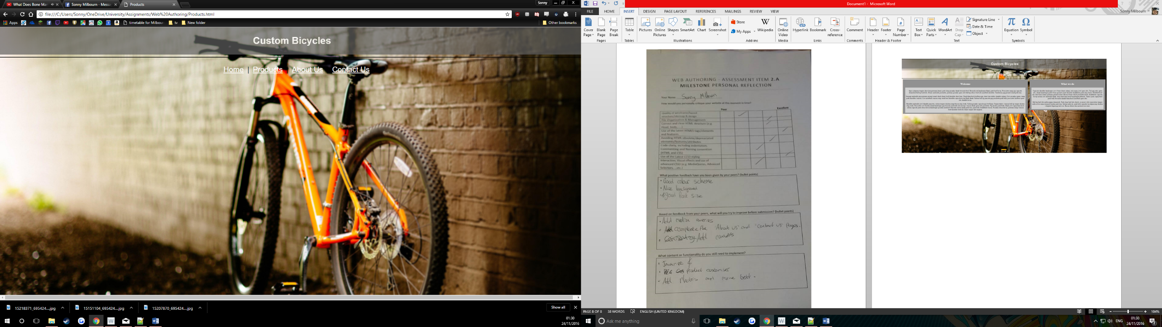Contact us page